Mid America Buckskin Association (MABA)
Sponsorship
The Indiana Buckskin Charter Annual Show
“Road to the Warm-Up Show” July 25, 2016
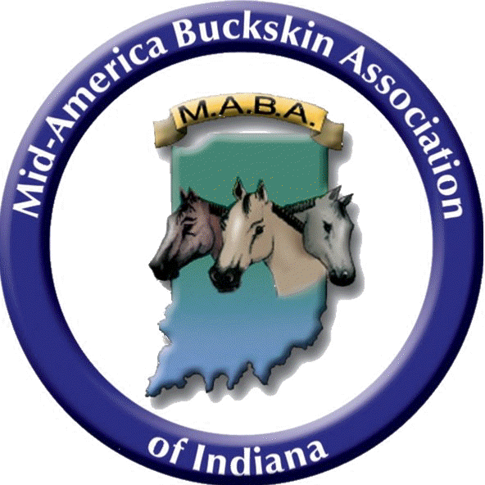
Sponsor’s Name: __________________________________________________
Street Address: ___________________________________________________
City: ________________________State: ________________Zip: ___________
Phone #: _________________________________________________________

Sponsors will be listed on Website, Facebook, Instagram & Announced at the show.
Check amount you would like to sponsor:
_____Platinum Sponsor - $500
_____Gold Sponsor - $200
_____Silver Sponsor - $150
_____Bronze Sponsor - $100
_____Specific Amount - $_____
Online Payment Accepted. Indianabuckskin.com
How would you like your sponsorship (Name) to read?
This Award Sponsored By: __________________________________________________
Please make check payable to: MABA
Send to: Becky Teeters
3650 Teeters Rd
Martinsville, IN 46151
(765) 913-9060

